GLocate

Version 1.1

Revision History

|  |  |  |  |
| --- | --- | --- | --- |
| **Date** | **Version** | **Description** | **Author** |
| 14/11/2019 | 1.0 | First version | Hồ Minh Trí |
| 18/11/2019 | 1.1 | Added use case model, more use case specifications | Hồ Minh Trí  Nguyễn Hoàng Tân |
|  |  |  |  |
|  |  |  |  |

Table of Contents

1. Use-case Model

2. Use-case Specifications

2.1 Use-case: Create a new account

2.2 Use-case: Sign in to account

2.3 Use-case: Sign out of account

2.4 Use-case: Create a new group

2.5 Use-case: Join a group

2.6 Use-case: Leave a group

2.7 Use-case: Change group's name

2.8 Use-case: View group's code

2.9 Use-case: Change group's code

2.10 Use-case: Pick new group leader

2.11 Use-case: Remove member from group

2.12 Use-case: View location of others

2.13 Use-case: Highlight a group member

2.14 Use-case: Un-highlight a group member

2.15 Use-case: Set meeting point

2.16 Use-case: Remove meeting point

2.17 Use-case: Edit profile

2.18 Use-case: View profile of others

2.19 Use-case: Group message

2.20 Use-case: Access database

# Use-case Model

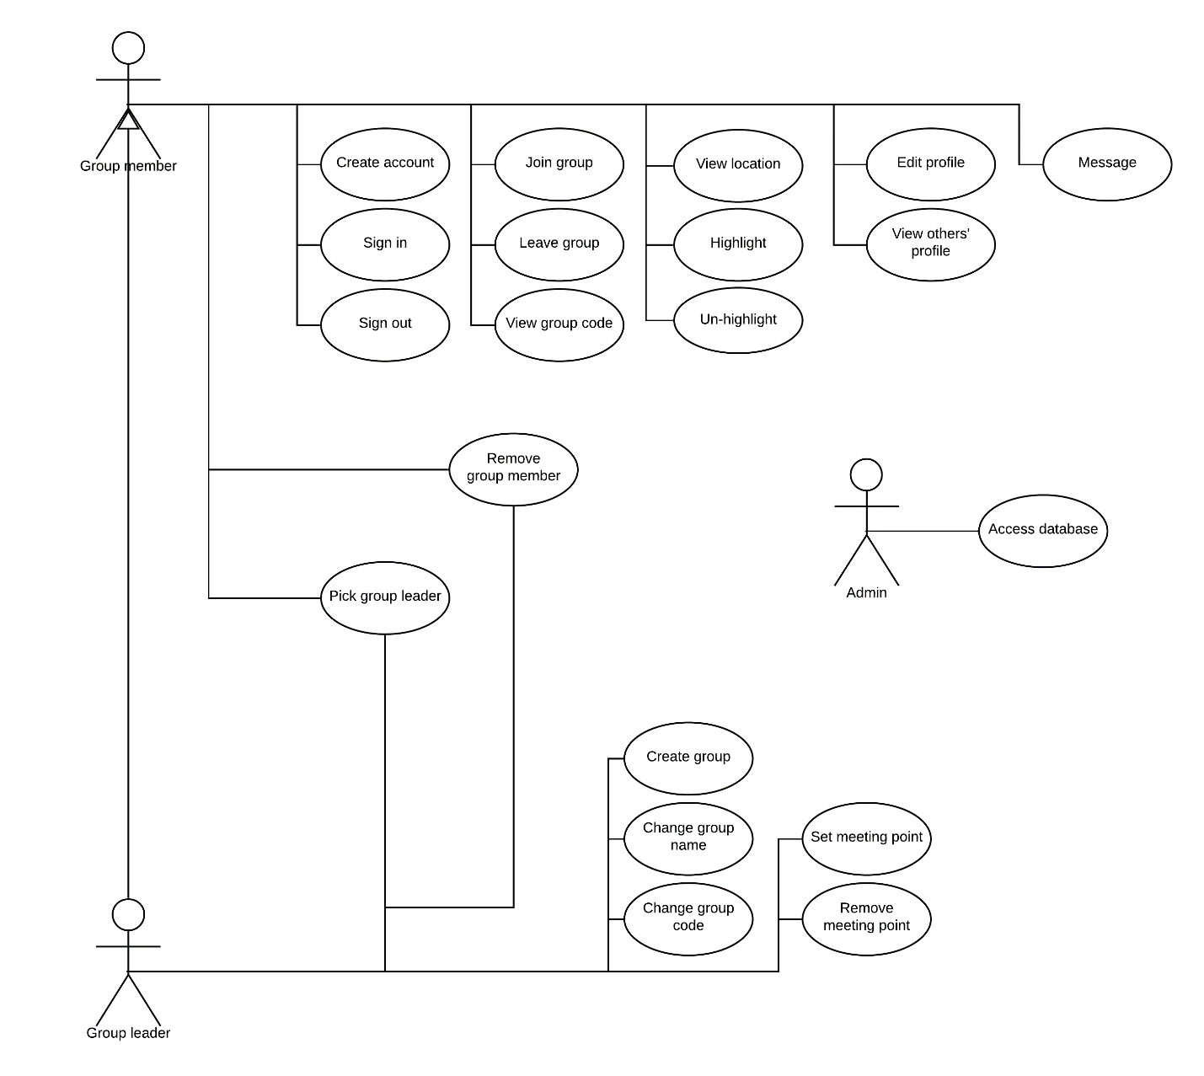

# Use-case Specifications

## Use-case: Create a new account

|  |  |
| --- | --- |
| Use case Name | Create a new account. |
| Brief description | This use case describes how a user can create a new account and become a Group member. |
| Actors | Group member. |
| Basic Flow | 1. From the app’s login interface, the user clicks the “Sign up” button 2. The app displays two fields to enter username and password 3. The user enters the username and password they want for their new account 4. The user clicks the “Create new account” button 5. The app creates a new account for the user 6. The user is signed in to their account 7. The user is transported to the app’s map interface |
| Alternative Flows | **Alternative flow 1: Username is already taken**   1. After step #4 in the basic flow, the app searches the database and finds that there is already a user with the entered username 2. The app notifies the user of this and requests the user to enter a different username 3. Step #3 in the basic flow is carried out again |
| Pre-conditions | The user opens the app. |
| Post-conditions | A new account is created for the user and the user is signed in to their account. |

## Use-case: Sign in to account

|  |  |
| --- | --- |
| Use case Name | Sign in to account. |
| Brief description | This use case describes how a Group member can sign in to their account. |
| Actors | Group member. |
| Basic Flow | 1. From the app’s login interface, the user enters their name and password into the appropriate fields 2. The user clicks the “Sign in” button 3. The user is signed in to their account 4. The user is transported to the app’s map interface |
| Alternative Flows | **Alternative flow 1: User has already signed in**   1. If the user has signed in before and has not signed out, when the user opens the app, they are automatically transported to the app’s map interface   **Alternative flow 2: Wrong username or password**   1. After step #2 in the basic flow, the app searches the database and cannot find any user with the username/password pair 2. The app notifies the user of this and asks the user to enter the username and password again 3. Step #1 in the basic flow is carried out again |
| Pre-conditions | The user has created an account. |
| Post-conditions | The user is signed in to their account. |

## Use-case: Sign out of account

|  |  |
| --- | --- |
| Use case Name | Sign out of account. |
| Brief description | This use case describes how a Group member can sign out of their account. |
| Actors | Group member. |
| Basic Flow | 1. From the app’s map interface, the user clicks the “Sign out” button 2. The user is signed out of their account 3. The user is transported to the app’s login interface |
| Alternative Flows |  |
| Pre-conditions | The user is signed in to their account. |
| Post-conditions | The user is signed out of their account. |

## Use-case: Create a new group

|  |  |
| --- | --- |
| Use case Name | Create a new group. |
| Brief description | This use case describes how a user can create a new group and become the Group leader of that group. |
| Actors | Group leader. |
| Basic Flow | 1. From the app’s map interface, the user clicks the “Groups” button 2. The user is moved to the groups interface 3. The user clicks the “Create group” button 4. The app displays a field for the user to enter the name of the new group 5. The user enters the name of the new group and clicks the “Create group” button 6. The app creates a new group with the user as the group leader 7. The app displays a piece of code to the user and instructs the user to send this piece of code to others for them to join the group 8. The user clicks the “Back to map” button 9. The user is transported back to the map interface |
| Alternative Flows | **Alternative flow 1: Group name is already taken**   1. After step #5 in the basic flow, the app searches the database and finds that there is already a group with the entered group name 2. The app notifies the user of this and requests the user to enter a different group name 3. Step #5 in the basic flow is carried out again |
| Pre-conditions | The user is signed in to their account. |
| Post-conditions | A new group is created with the user as the first member. The user has a piece of code to send to others to invite them to join the group. |

## Use-case: Join a group

|  |  |
| --- | --- |
| Use case Name | Join a group. |
| Brief description | This use case describes how a Group member can join a group. |
| Actors | Group member. |
| Basic Flow | 1. From the app’s map interface, the user clicks the “Groups” button 2. The user is moved to the groups interface 3. The user clicks the “Join group” button 4. The app displays a field for the user to enter a group’s code 5. The user enters a piece of code into the field and clicks the “Join group” button 6. The app adds the user to the group with the matching code 7. The app notifies the user they are now a new member of a group, and the app reports the name of the group to the user 8. The user clicks the “Back to map” button 9. The user is transported back to the map interface |
| Alternative Flows | **Alternative flow 1: User is already member of the group**   1. After step #5 in the basic flow, the app searches the database and finds that the user is already a member of the group with the matching code 2. The app notifies the user of this 3. The user clicks the “Back to map” button 4. The user is transported back to the map interface   **Alternative flow 2: Wrong code**   1. After step #5 in the basic flow, the app searches the database and finds that there is no group that matches the code the user enters 2. The app notifies the user of this and asks them to enter a new piece of code 3. Step #5 in the basic flow is carried out again |
| Pre-conditions | The user has a piece of code to join a group, retrieved from somewhere. |
| Post-conditions | The user is a new member of the group. |

## Use-case: Leave a group

|  |  |
| --- | --- |
| Use case Name | Leave a group. |
| Brief description | This use case describes how a Group member can leave a group. |
| Actors | Group member. |
| Basic Flow | 1. From the app’s map interface, the user clicks the “Groups” button 2. The user is shown a list of groups that they are a member of 3. The user scrolls the list and finds the group that they want to leave 4. The user clicks the “Leave” button next to the name of the group 5. The app removes the user from the group 6. The groups list is refreshed and the group the user just left is no longer in the list |
| Alternative Flows | **Alternative flow 1: User is group leader**   1. At step #4 in the basic flow, if the user is the leader of the group and there is still some other member in the group then there is no “Leave” button next to the name of the group 2. The user needs to pick another group member as the group leader first before they can leave the group |
| Pre-conditions | The user is a member of a group. |
| Post-conditions | The user is no longer a member of the group. |

## Use-case: Change group’s name

|  |  |
| --- | --- |
| Use case Name | Change group’s name. |
| Brief description | This use case describes how the Group leader of a group can change the name of the group. |
| Actors | Group leader. |
| Basic Flow | 1. From the app’s map interface, the user clicks the “Groups” button 2. The user is shown a list of groups that they are a member of, with the groups that they are a leader of at the top with a “Leader” label next to the group name 3. The user scrolls the list of groups they are a leader of to find the group that they want to change the group name 4. The user clicks on the group name 5. The user is shown information about the group 6. The user clicks on the “Change group name” button 7. The app displays a field for the user to enter the new name of the group 8. The user enters the new name of the group and clicks the “Change group name” button 9. The name of the group is change to the name entered by the user |
| Alternative Flows | **Alternative flow 1: Group name is already taken**   1. After step #8 in the basic flow, the app searches the database and finds that there is already a group with the entered group name 2. The app notifies the user of this and requests the user to enter a different group name 3. Step #8 in the basic flow is carried out again   **Alternative flow 2: No button to change group name**   1. At step #6 in the basic flow, if there is no “Change group name” button then this means that the user is not the leader of the group 2. The user can only change group name for the groups that they are the group leader |
| Pre-conditions | The user is a member of a group. |
| Post-conditions | The name of the group is changed. |

## Use-case: View group’s code

|  |  |
| --- | --- |
| Use case Name | View group’s code. |
| Brief description | This use case describes how a Group member can view the code of a group they are a member of, so that they can send this code to others to invite them to join the group. |
| Actors | Group member. |
| Basic Flow | 1. From the app’s map interface, the user clicks the “Groups” button 2. The user is shown a list of groups that they are a member of 3. The user scrolls the list and finds the group that they want to view the code of 4. The user clicks on the group name 5. The user is shown information about the group 6. The user clicks on the “Show code” button 7. The app displays a modal showing the code of the group 8. The user can send this piece of code to others to invite them to join the group 9. The user clicks on the “Close” button in the modal to close the modal |
| Alternative Flows |  |
| Pre-conditions | The user is a member of a group. |
| Post-conditions | The user can view the code of the group. |

## Use-case: Change group’s code

|  |  |
| --- | --- |
| Use case Name | Change group’s code. |
| Brief description | This use case describes how the Group leader of a group can change the code of the group, for example because they suspect that some outsider has stolen the code and might use it to spy on the group. |
| Actors | Group leader. |
| Basic Flow | 1. From the app’s map interface, the user clicks the “Groups” button 2. The user is shown a list of groups that they are a member of, with the groups that they are a leader of at the top with a “Leader” label next to the group name 3. The user scrolls the list of groups they are a leader of to find the group that they want to change the group code 4. The user clicks on the group name 5. The user is shown information about the group 6. The user clicks on the “Generate new group code” button 7. A new code is generated for the group and the old code is discarded 8. The app displays the new piece of code to the user 9. The user clicks the “Back to map” button 10. The user is transported back to the map interface |
| Alternative Flows | **Alternative flow 1: No button to change group code**   1. At step #6 in the basic flow, if there is no “Generate new group code” button then this means that the user is not the leader of the group 2. The user can only change group code for the groups that they are the group leader |
| Pre-conditions | The user is a member of a group. |
| Post-conditions | A new code is generated for the group. |

## Use-case: Pick new group leader

|  |  |
| --- | --- |
| Use case Name | Pick new group leader. |
| Brief description | This use case describes how the Group leader of a group can pick another Group member as the new Group leader. |
| Actors | Group leader, Group Member. |
| Basic Flow | 1. From the app’s map interface, the user clicks the “Groups” button 2. The user is shown a list of groups that they are a member of, with the groups that they are a leader of at the top with a “Leader” label next to the group name 3. The user scrolls the list of groups they are a leader of to find the group that they want to pick a new group leader 4. The user clicks on the group name 5. The user is shown a list of members in the group 6. The user scrolls the list to find the member that they want to pick as the new group leader 7. The user clicks the “Pick as group leader” button next to the group member’s username 8. The user is no longer the group leader with the group member as the new group leader |
| Alternative Flows | **Alternative flow 1: No button to pick new group leader**   1. At step #7 in the basic flow, if there is no “Pick as group leader” button next to the group member’s username then this means that the user is not the leader of the group 2. The user can only pick new group leaders for the groups that they are the group leader |
| Pre-conditions | The user is the leader of a group. |
| Post-conditions | The user is no longer the leader of the group with another group member as the new group leader. |

## Use-case: Remove member from group

|  |  |
| --- | --- |
| Use case Name | Remove member from group. |
| Brief description | This use case describes how the Group leader of a group can remove a Group member from the group. |
| Actors | Group leader, Group Member. |
| Basic Flow | 1. From the app’s map interface, the user clicks the “Groups” button 2. The user is shown a list of groups that they are a member of, with the groups that they are a leader of at the top with a “Leader” label next to the group name 3. The user scrolls the list of groups they are a leader of to find the group that they want to remove a group member 4. The user clicks on the group name 5. The user is shown a list of members in the group 6. The user scrolls the list to find the member that they want to remove from the group 7. The user clicks the “Remove” button next to the group member’s username 8. The group member is removed from the group |
| Alternative Flows | **Alternative flow 1: No button to remove group member**   1. At step #7 in the basic flow, if there is no “Remove” button next to the group member’s username then this means that the user is not the leader of the group 2. The user can only remove group members for the groups that they are the group leader |
| Pre-conditions | The user is the leader of a group. |
| Post-conditions | A group member is removed from the group. |

## Use-case: View location of others

|  |  |
| --- | --- |
| Use case Name | View location of others. |
| Brief description | This use case describes how a Group member can view the location of others. |
| Actors | Group member. |
| Basic Flow | 1. In the app’s map interface, the user is shown the real time location of themselves and every member of every group that they are a part of 2. Each user is shown on the map as a dot designating their location along with their profile picture and their username 3. The user can scroll and zoom in and zoom out on the map to get a better look at those on the map |
| Alternative Flows | **Alternative flow 1: No one other than the user is shown on the map**   1. If the user is not a member of any group then only their location is visible on the map 2. The user needs to join a group first in order to view the locations of the members in the group |
| Pre-conditions | The user is a member of a group. |
| Post-conditions | The user can see the locations of others in the group. |

## Use-case: Highlight a group member

|  |  |
| --- | --- |
| Use case Name | Highlight a group member. |
| Brief description | This use case describes how a Group member can highlight another Group member on the map. |
| Actors | Group member. |
| Basic Flow | 1. From the app’s map interface, the user clicks the “Groups” button 2. The user is shown a list of groups that they are a member of 3. The user scrolls the list to find the group that contain the member they want to highlight 4. The user clicks on the group name 5. The user is shown a list of members in the group 6. The user scrolls the list to find the member that they want to highlight 7. The user clicks the “Highlight” button next to the group member’s username 8. The group member is now highlighted on the map, and there is also an arrow pointing from the user to the group member along with the distance between the two |
| Alternative Flows | **Alternative flow 1: Group member is already highlighted**   1. At step #7 in the basic flow, if the group member that the user wants to highlight is already highlighted, there will only be an “Un-highlight” button next to the group member’s username 2. The user does not need to do anything if they want the group member to be highlighted |
| Pre-conditions | The user is a member of a group. |
| Post-conditions | The group member is highlighted on the map, with an arrow pointing from the user to the member along with the distance between the two. |

## Use-case: Un-highlight a group member

|  |  |
| --- | --- |
| Use case Name | Un-highlight a group member. |
| Brief description | This use case describes how a Group member can un-highlight a highlighted Group member. |
| Actors | Group member. |
| Basic Flow | 1. From the app’s map interface, the user clicks the “Groups” button 2. The user is shown a list of groups that they are a member of 3. The user scrolls the list to find the group that contain the member they want to un-highlight 4. The user clicks on the group name 5. The user is shown a list of members in the group 6. The user scrolls the list to find the member that they want to un-highlight 7. The user clicks the “Un-highlight” button next to the group member’s username 8. The group member is now no longer highlighted on the map and the arrow and distance between the user and the group member is also removed |
| Alternative Flows | **Alternative flow 1: Group member is not highlighted**   1. At step #7 in the basic flow, if the group member that the user wants to highlight is not highlighted, there will only be a “Highlight” button next to the group member’s username 2. The user does not need to do anything if they do not want the group member to be highlighted |
| Pre-conditions | A group member is highlighted on the map. |
| Post-conditions | The group member is no longer highlighted on the map. |

## Use-case: Set meeting point

|  |  |
| --- | --- |
| Use case Name | Set meeting point. |
| Brief description | This use case describes how the Group leader of a group can set the meeting point for the group. |
| Actors | Group leader. |
| Basic Flow | 1. From the app’s map interface, the user clicks the “Groups” button 2. The user is shown a list of groups that they are a member of, with the groups that they are a leader of at the top with a “Leader” label next to the group name 3. The user scrolls the list of groups they are a leader of to find the group that they want to set the meeting point 4. The user clicks on the group name 5. The user clicks the “Set meeting point” button 6. The user is shown the map interface. Clicking on the map for the first time causes a flag to be placed at the clicked-on position. Clicking on the map afterwards causes the flag to be moved to the new clicked-on position 7. The user scrolls and clicks on the map until the flag is at the desired meeting point location 8. The user clicks on the “Set meeting point” button 9. A new meeting point for the group is set at the location of the flag. Each member in the group will be shown an arrow pointing from their location to the meeting point location, along with the distance between the two |
| Alternative Flows | **Alternative flow 1: A meeting point has already been set**   1. If a meeting point has already been set for the group then after step #5 in the basic flow, the old meeting point is removed and the new meeting point is set   **Alternative flow 2: No button to set meeting point**   1. At step #5 in the basic flow, if there is no “Set meeting point” button then this means that the user is not the leader of the group 2. The user can only set the meeting point for the groups that they are the group leader |
| Pre-conditions | The user is the leader of a group. |
| Post-conditions | A meeting point is set for the group. |

## Use-case: Remove meeting point

|  |  |
| --- | --- |
| Use case Name | Remove meeting point. |
| Brief description | This use case describes how the Group leader of a group can remove the meeting point of the group. |
| Actors | Group leader. |
| Basic Flow | 1. From the app’s map interface, the user clicks the “Groups” button 2. The user is shown a list of groups that they are a member of, with the groups that they are a leader of at the top with a “Leader” label next to the group name 3. The user scrolls the list of groups they are a leader of to find the group that they want to remove the meeting point 4. The user clicks on the group name 5. The user clicks the “Remove meeting point” button 6. The meeting point of the group is removed. Each member in the group no longer has an arrow pointing from their location to the meeting point |
| Alternative Flows | **Alternative flow 1: Group has not set meeting point**   1. At step #5 in the basic flow, if the group has not set the meeting point then there is no “Remove meeting point” button 2. The user does not need to do anything if they do not want the group to have a meeting point   **Alternative flow 2: No button to remove meeting point**   1. At step #5 in the basic flow, if the group has set the meeting point but there is no “Remove meeting point” button then this means that the user is not the leader of the group 2. The user can only remove the meeting point for the groups that they are the group leader |
| Pre-conditions | The user is the leader of a group. |
| Post-conditions | The meeting point of the group is removed. |

## Use-case: Edit profile

|  |  |
| --- | --- |
| Use case Name | Edit profile. |
| Brief description | This use case describes how a Group member can edit their profile. |
| Actors | Group member. |
| Basic Flow | 1. In the app’s map interface, click the “Profile” button 2. The user is shown their profile, including information like profile picture, real name, phone number, etc. 3. The user can then choose to add, edit, or delete information about themselves, such as add a profile picture or edit the self-description |
| Alternative Flows |  |
| Pre-conditions | The user is signed in to their account. |
| Post-conditions | The profile of the user is updated. |

## Use-case: View profile of others

|  |  |
| --- | --- |
| Use case Name | View profile of others. |
| Brief description | This use case describes how a Group member can view the profile of others. |
| Actors | Group member. |
| Basic Flow | 1. From the app’s map interface, the user clicks the “Groups” button 2. The user is shown a list of groups that they are a member of 3. The user scrolls the list to find the group that contain the member they want to view the profile 4. The user clicks on the group name 5. The user is shown a list of members in the group 6. The user scrolls the list to find the member that they want to view the profile 7. The user clicks on the username of the member 8. The user is shown the profile of the member, including information like profile picture, real name, phone number, etc. |
| Alternative Flows |  |
| Pre-conditions | The user is a member of a group. |
| Post-conditions | The user can view the profile of another group member. |

## Use-case: Group message

|  |  |
| --- | --- |
| Use case Name | Group message. |
| Brief description | This use case describes how a Group member can access the group message functionality. |
| Actors | Group member. |
| Basic Flow | 1. In the app’s map interface, the user clicks the “Message” button 2. The user is moved to the group message interface. 3. On the left-hand side is a list of groups the user is a member of. The user clicks on the name of the group the user wants to view and post messages to. 4. On the right-hand side is a list of messages posted by members of the group, sorted from newest to oldest. 5. The user can post a message to the group by entering into the “Post a message” field and click the “Post” button |
| Alternative Flows |  |
| Pre-conditions | The user is a member of a group. |
| Post-conditions | The user can see messages posted by others and can also post messages to the group. |

## Use-case: Access database

|  |  |
| --- | --- |
| Use case Name | Access database. |
| Brief description | This use case describes how an Admin can access the Firebase database containing the app’s data. |
| Actors | Admin. |
| Basic Flow | 1. The user goes to <https://firebase.google.com> and sign in using their admin’s username and password 2. The user clicks the “Go to console” button 3. The user clicks on the name of the project, which is “TNT Project” 4. The user clicks the “Database” button 5. The user is shown the database containing the app data, which includes the information about every user and every group in the app 6. The user can choose to edit the database, such as to reset the password of a user or to delete a group |
| Alternative Flows | **Alternative flow 1: Wrong username or password**   1. After step #1 in the basic flow, if the entered username/password pair does not match any then the user is notified of this and is asked to enter again 2. Step #1 in the basic flow is carried out again   **Alternative flow 2: Project not found**   1. At step #3 in the basic flow, if the name of the project is not found then this means that the user has not been shared access to the project 2. The user needs to somehow acquire access to the project |
| Pre-conditions | The user is an admin. |
| Post-conditions | The user can view the database containing the app’s data and can also edit the database. |